+Date: 6th February 2024

T1. Create a webpage that has a heading and a button. Write a script to change the background color and text when the button is clicked.

⇒ <!DOCTYPE html>

<html lang="en">

<head>

<meta charset="UTF-8">

<meta name="viewport" content="width=device-width, initial-scale=1.0">

<title>Color Changing</title>

<style>

body {

text-align: center;

margin: 50px;

font-family: Arial, sans-serif;

}

h1 {

color: black;

}

button {

padding: 10px 20px;

font-size: 16px;

cursor: pointer;

}

</style>

</head>

<body>

<h1 id="mainHeading">Welcome to Color Change </h1>

<button onclick="changeColors()">Change Colors</button>

<script>

function changeColors() {

var heading = document.getElementById("mainHeading");

var body = document.body;

body.style.backgroundColor = "lightblue";

heading.style.color = "white";

heading.textContent = "Colors Changed!(\*-\*)";

}

</script>

</body>

</html>

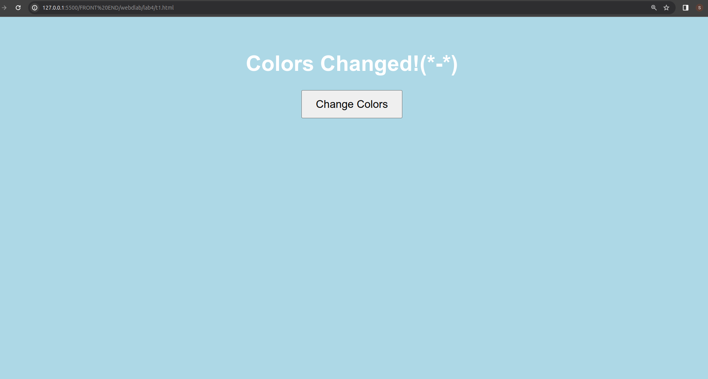

T2. For T1, experiment with the Javascript code by trying the following things: a. Make the background light green.

b. Add a line that makes the text red.

c. Change the fontSize to 48pt.

d. Change the wording inside the <h1> tag in the Javascript.

e. Add <button>Click Me</button> after the closing </h1>.

⇒ <!DOCTYPE html>

<html lang="en">

<head>

<meta charset="UTF-8">

<meta name="viewport" content="width=device-width, initial-scale=1.0">

<title>Experiment with JavaScript</title>

<style>

body {

background-color: lightgreen;

color: black;

}

</style>

</head>

<body>

<h1 id="myHeading">Original Text</h1>

<script>

document.getElementById("myHeading").style.color = "red";

document.getElementById("myHeading").style.fontSize = "48pt";

document.getElementById("myHeading").innerHTML = "New Heading Text";

var button = document.createElement("button");

button.innerHTML = "Click Me";

document.body.appendChild(button);

</script>

</body>

</html>

: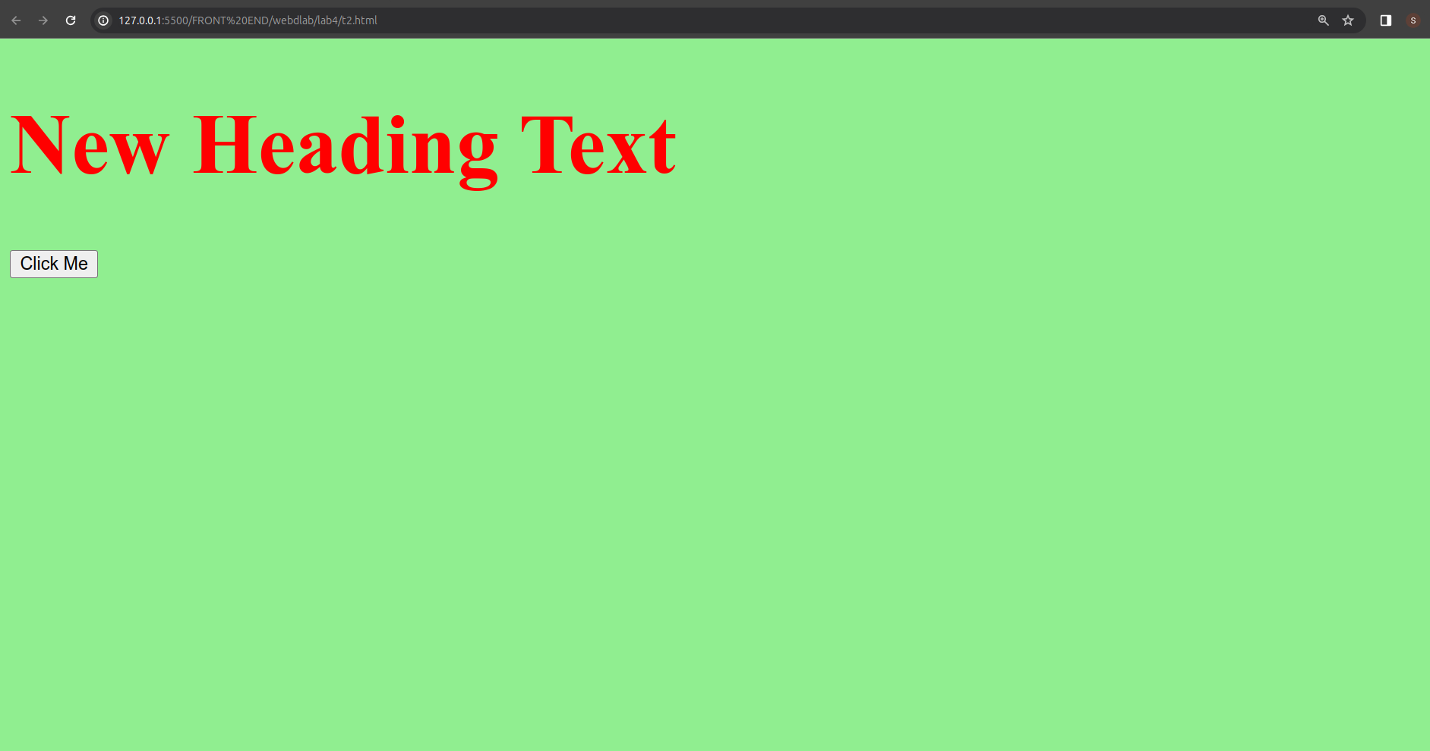

T3. For T1, set the color of the background directly with the class attribute. Generate alerts before and after assigning the class attribute to document object.

<!DOCTYPE html>

<html lang="en">

<head>

<meta charset="UTF-8">

<meta name="viewport" content="width=device-width, initial-scale=1.0">

<title>Dynamic Background</title>

<style>

.background-color-class {

background-color: lightblue;

}

</style>

</head>

<body>

<h1 id="dynamicElement">Initial Heading</h1>

<button onclick="changeStyle()">Change Style</button>

<script>

function changeStyle() {

alert("Before assigning the class attribute");

var element = document.getElementById("dynamicElement");

element.className = "background-color-class";

alert("After assigning the class attribute");

}

</script>

</body>

</html>

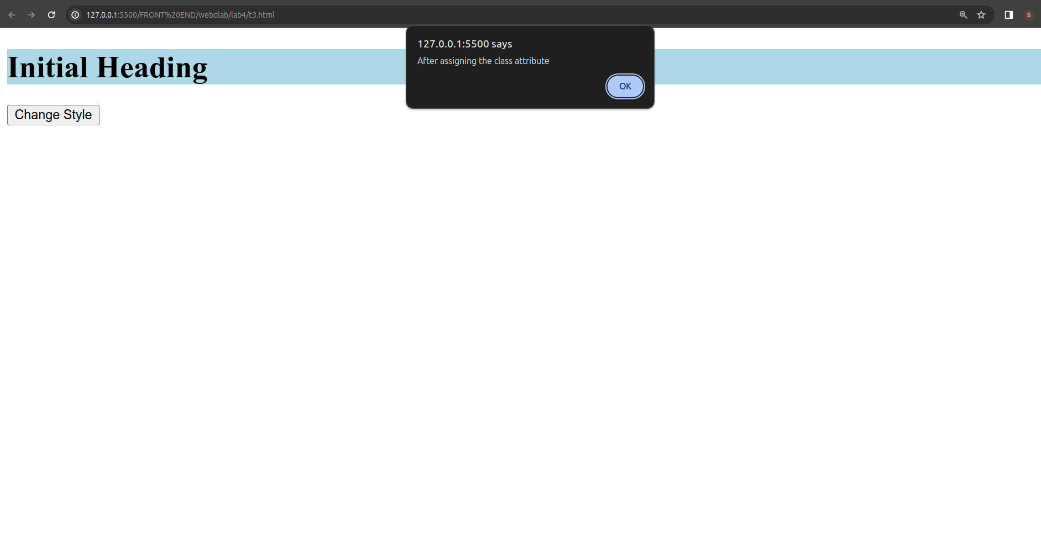

T4. Design a page having contents within and outside the main section. The page must contain a button that when clicked replaces the content of the main section with another content having different style.

⇒ <!DOCTYPE html>

<html lang="en">

<head>

<meta charset="UTF-8">

<meta name="viewport" content="width=device-width, initial-scale=1.0">

<title>Dynamic Content Replacement</title>

<style>

body {

font-family: Arial, sans-serif;

margin: 0;

padding: 0;

background-color: #f0f0f0;

}

header {

background-color: #333;

color: #fff;

text-align: center;

padding: 10px;

}

main {

margin: 20px;

padding: 20px;

background-color: #fff;

box-shadow: 0 0 10px rgba(0, 0, 0, 0.1);

}

#content1 {

color: #333;

}

#content2 {

color: #fff;

background-color: #4CAF50;

padding: 15px;

border-radius: 5px;

}

button {

padding: 10px;

background-color: #333;

color: #fff;

border: none;

cursor: pointer;

}

</style>

</head>

<body>

<header>

<h1>Dynamic Content Replacement</h1>

</header>

<main id="mainSection">

<div id="content1">

<p>This is the initial content of the main section.</p>

</div>

</main>

<button onclick="replaceContent()">Replace Content</button>

<script>

function replaceContent() {

var mainSection = document.getElementById("mainSection");

var newContent = document.createElement("div");

newContent.id = "content2";

newContent.innerHTML = "<p>This is the replaced content with different style.</p>";

mainSection.innerHTML = "";

mainSection.appendChild(newContent);

}

</script>

</body>

</html>

: 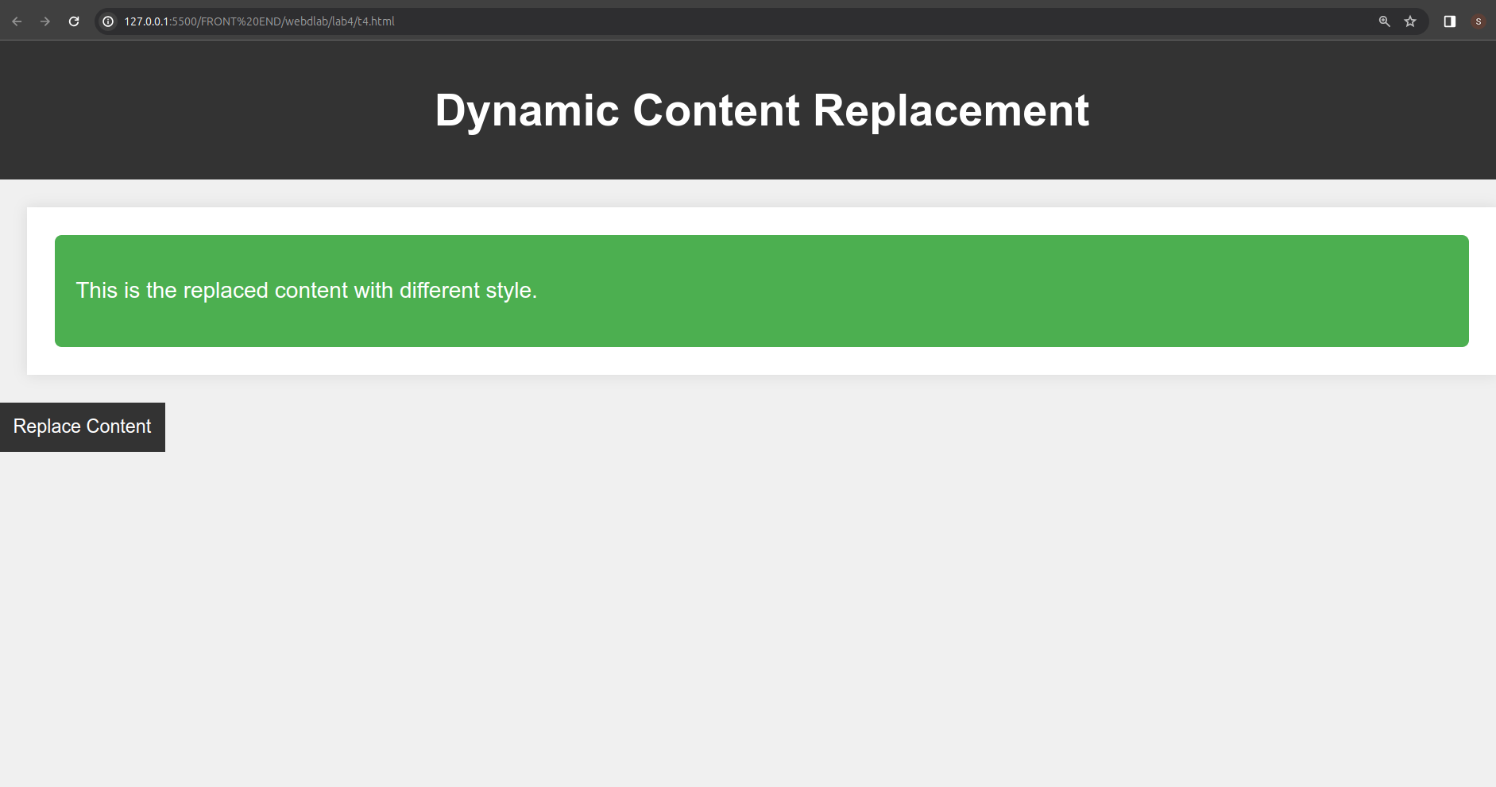

T5. Consider a h1 heading lying outside the main section in the page. Try changing the color of h1 in at least 3 different ways.

⇒ <!DOCTYPE html>

<html lang="en">

<head>

<meta charset="UTF-8">

<meta name="viewport" content="width=device-width, initial-scale=1.0">

<title>Change h1 Color</title>

<style>

body {

font-family: Arial, sans-serif;

margin: 0;

padding: 0;

background-color: #f0f0f0;

}

header {

background-color: #333;

color: #fff;

text-align: center;

padding: 10px;

}

h1 {

margin: 20px;

padding: 20px;

color: #333;

}

</style>

</head>

<body>

<header>

<h1>Heading Outside Main Section</h1>

</header>

<main id="mainSection">

<div id="content1">

<p>This is the initial content of the main section.</p>

</div>

</main>

<button onclick="replaceContent()">Replace Content</button>

<script>

function replaceContent() {

var mainSection = document.getElementById("mainSection");

var newContent = document.createElement("div");

newContent.id = "content2";

newContent.innerHTML = "<p>This is the replaced content with different style.</p>";

mainSection.innerHTML = "";

mainSection.appendChild(newContent);

}

</script>

</body>

</html>

: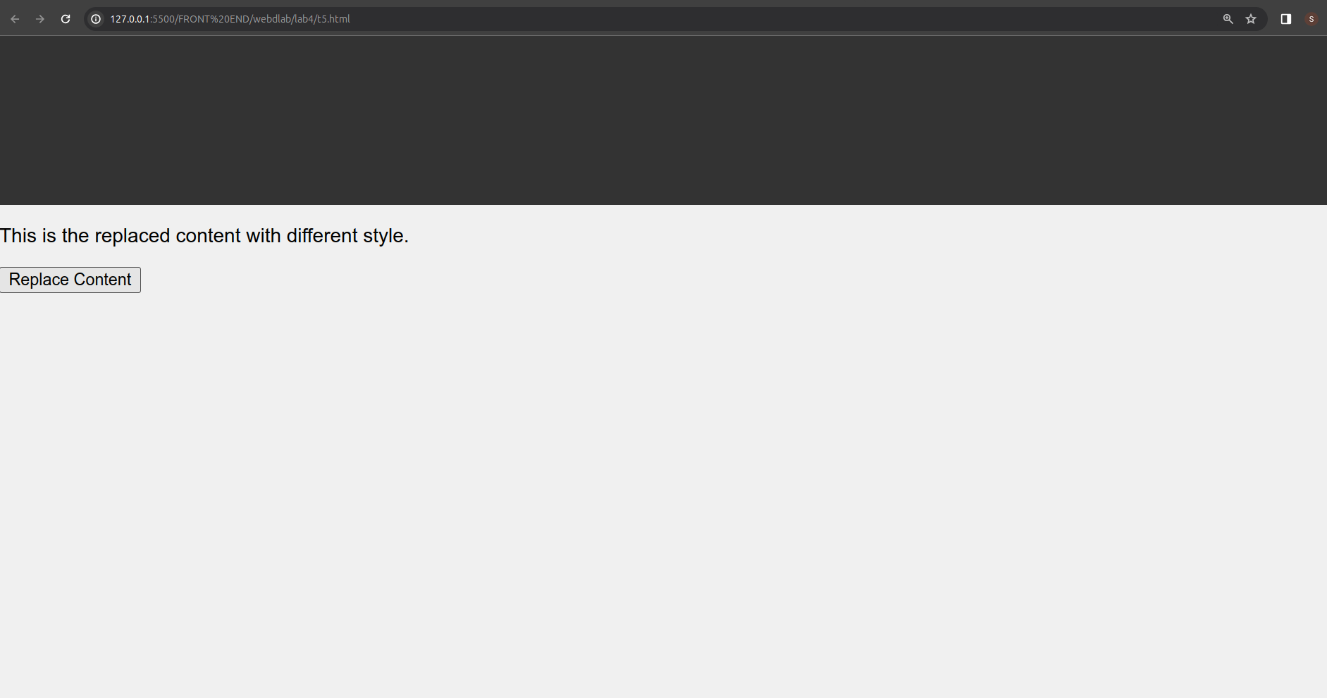

T6. Design a webpage using grid layout that displays the following:

The first row shows icons of various web browsers and the second row shows the latest version number.

<!DOCTYPE html>

<html lang="en">

<head>

<meta charset="UTF-8">

<meta name="viewport" content="width=device-width, initial-scale=1.0">

<title>Web Browser Versions</title>

<style>

body {

font-family: Arial, sans-serif;

margin: 0;

padding: 0;

box-sizing: border-box;

}

.grid-container {

display: grid;

grid-template-rows: auto auto;

grid-template-columns: repeat(5, 1fr);

gap: 10px;

padding: 20px;

}

.browser-icon {

width: 100%;

height: auto;

text-align: center;

}

.browser-icon img {

width: 100px;

}

.version-number {

text-align: center;

background-color: #f2f2f2;

padding: 10px;

}

</style>

</head>

<body>

<div class="grid-container">

<div class="browser-icon"><img src="chrome-icon.png" alt="Chrome"></div>

<div class="browser-icon"><img src="firefox-icon.png" alt="Firefox"></div>

<div class="browser-icon"><img src="edge-icon.png" alt="Edge"></div>

<div class="browser-icon"><img src="safari-icon.png" alt="Safari"></div>

<div class="browser-icon"><img src="opera-icon.png" alt="Opera"></div>

<div class="version-number">Chrome<br>Version 100.0</div>

<div class="version-number">Firefox<br>Version 99.0</div>

<div class="version-number">Edge<br>Version 20.0</div>

<div class="version-number">Safari<br>Version 15.0</div>

<div class="version-number">Opera<br>Version 75.0</div>

</div>

</body>

</html>

: